

Create a Payzone UK payment skin

Copyright : Payzone UK 2016

Skinning the HOSTED PAYMENT FORM

Contents

Table of Contents

Introduction 3

Overview 3

What do we mean by a ‘skin’? 3

Creating the skin 4

The HTML 5

Images 6

Stylesheets 6

Javascript 7

Submit your skin 7

Need help? Get in touch: 7

# Introduction

## Overview

This is a technical document intended to help a web developer produce a new ‘look and feel’ for the Hosted Payment form provided for the Payzone UK payment gateway. A sample web site is provided containing stylesheet, images and HTML to demonstrate a skin, and to allow a developer to produce a skin before submitting it to us for approval.

## What do we mean by a ‘skin’?

The page provided by us for the payment gateway is a functional HTML page that enables a user to make a payment via the Payzone UK payment gateway. By default it looks like this:

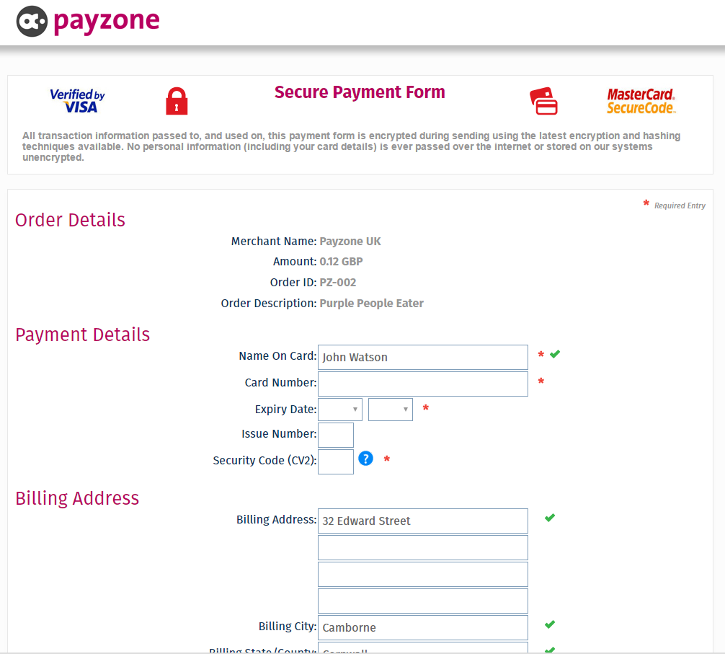

However a website may still require the functionality of the page, but would prefer it to look more like the rest of the website. To do this a web developer will provide us with a new CSS (stylesheet) file, any required images and a replacement HTML file (in the format described later). We will then check that it is to standard and will not break the page, and if acceptable will add it to the gateway so that when a request from your merchant id is received – the page will be presented the way you want it using the skin you provided.

## Creating the skin

### The HTML

You can create as advanced a HTML page as you require, provided that you follow a few rules.

There must be a standard <body> tag that matches this:

<body onload="ApplicationLoadHandler();">

<!-- DO NOT REMOVE THESE 2 DIVS UNLESS YOU DON'T WANT THE AJAX PROGRESS PANEL -->

<div id="AJAXUpdatePanel_Panel" style="display:none;"></div>

<div id="AJAXUpdatePanel_Spinner" style="display:none;"></div>

You must also add in two standard placeholders in your page:

@@DefaultStyleFiles@@

This must be placed in the <head> area before any stylesheets.

@@Content@@

Place this in the body inside a <div> where you want the payment form to appear.

The placeholders and the body tag must be present in the form or it will be rejected by us.

#### Example of <head>

<head>

@@DefaultStyleFiles@@

<!-- ANY REFERENCES TO YOUR OWN CSS FILES OR ANY STYLE TAGS CONTAINING CSS RULES -->

<!-- MUST GO **AFTER** THIS COMMENT -->

<title>Secure Payment Form</title>

<link id="MainSiteStyleSheet" href="CSS/StyleSheet.css" rel="stylesheet" type="text/css" />

</head>

#### Example of content placeholder

<div id="form_container">

<div id="form_bg">

<div id="form_padding">

<p>

<span class="form_gateway_text">Payzone Gateway</span> <span class="form_gateway_text">from Payzone</span>

</p>

@@Content@@

</div>

</div>

</div>

### Images

Please optimize the images to keep them as small as possible – it will speed up the delivery of the payment form. We can only accept images that are of types: .jpg, .gif, .png. Only supply images that are actually used on the HTML page, unused images will be deleted.

### Stylesheets

Because various browsers support different CSS attributes in different ways, we suggest that the HTML page once skinned be tested against a range of browsers before sending it to us. This will ensure that the display is to your liking for each browser. Payzone UK cannot accept any responsibility if the display of your skinned page does not render well in any particular browser.

If you supply a stylesheet then it can contain new classes used in the HTML – for example

HTML - <span class="form_gateway_text">Payzone Gateway</span>

CSS - #form_gateway_text { color: #f01e14; font-size: 19px; }

You can also override any classes used by the gateways own CSS by referencing them inside your own CSS. For example :-

Our CSS - .ContentHeader

{

font-size:18px;

padding-top:0px;

color:#929292;

width: 140px;

text-align: right;

padding-right: 65px;

background-position: top right;

}

Supplied CSS - .ContentHeader

{

font-size:24px;

padding-top:1px;

color:#b800600;

width: 280px;

text-align: right;

padding-right: 35px;

background-position: top right;

}

Your CSS will override any of our CSS classes with the same name.

### Javascript

You can include your own Javascript in the HTML – either as inline script or as an attached Javascript file, but like images keep this as small as possible to keep the render time short.

## Submit your skin

When you have completed and tested your new skin zip up the files and send them to us via email to [enquiries@payzone.co.uk](mailto:enquiries@payzone.co.uk) Please ensure you also supply your merchant name and ID to use so that we can add the skin to the correct account.

### Need help? Get in touch:

[enquiries@payzone.co.uk](mailto:enquiries@payzone.co.uk) 0844 2090 555